FOR IMMEDIATE RELEASE
Contact: Elisa Vásquez, (323) 890-7415, Elisa.Vasquez@lacdc.org

UCLA MOBILE EYE CLINIC ROLLS INTO
SOUTH WHITTIER
Healthy Eyes Makes for Success in the Classroom
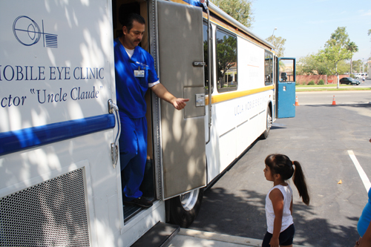
South Whittier, August 15, 2012 - August is Children’s Eye Health and Safety Month, which is also the time when families begin to prepare for the new school year. The UCLA Mobile Eye Clinic, a 40-foot-long coach, made its way to the Community Resource Center (CRC) to provide basic eye exams for 30 low-income children. Patients were tested by the eye clinic’s Ophthalmologist and Optometrist, received free prescription eyeglasses as well as referrals for future treatment.
Rene Galvan, Optometrist, UCLA Mobile Eye Clinic, welcomes Sonia Garcia to her first eye exam.
The UCLA Mobile Eye Clinic provides high-quality eye care to underserved populations—particularly children and the elderly—who lack access to health care as a result of finances, lack of transportation, or cultural and language barriers. “Teaching children to protect their eyes is an important early lesson toward a lifetime of healthy vision. It is vital to educate parents on the importance of their children’s eyes, especially with the first day of school just around the corner. We want all our children to be star students in the classroom,” said Los Angeles County Supervisor Don Knabe, who represents the area.
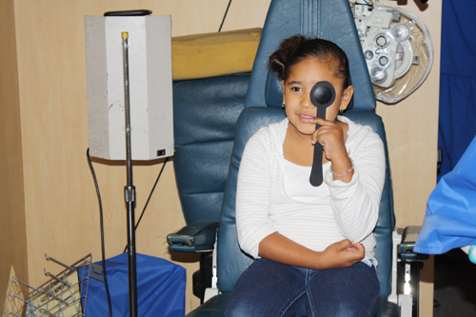
The UCLA Mobile Eye Clinic, established in 1975 by an anonymous donor, remains a privately funded outreach program operated by the Jules Stein Eye Institute. Their mission is to discover eye diseases or eye problems and try to get people connected to the care they need. Each year, the UCLA Ophthalmologists provide 4,000 children and 1,000 adult examinations free of charge. In addition, they also provide 1,500 vision and glaucoma screenings at community events, and supply 400 free prescription glasses to underserved children.
Ruby Retana enjoys her eye exam.
A project of the Community Development Commission of the County of Los Angeles (CDC), the Community Resource Center is funded by the Fourth Supervisorial District, and works in collaboration with its onsite service providers to offer health, wellness, and educational programs for families, seniors, and youth.
Santiago Vargas and Optometrist Rene Galvan take part in a vision glaucoma screening.
The CRC is located at 10750 Laurel Avenue in South Whittier. For information on services provided by the CRC, please call (562) 946-2425, or visit the website at www.swcrc.org. All media may contact Elisa Vásquez, CDC Public Information Officer, at (323) 890-7415.
###

